**Institute of Computer Technology**

**B. Tech. Computer Science and Engineering**

**Semester: III**

**Sub: Object-Oriented Programming**

**Course Code: 2CSE303**

**Practical Number:1**

**Objective:**

*To learn about sample Java program by using class, method, variable, data type,*

*System.out.println (), Scanner class, and format specification.*

Q.1.Problem Definition:

Ajay and Vijay are two students studying Java programming. They have been given a task by their instructor to swap the values of two variables. They have to demonstrate two methods: one using a third variable, and the other without using a third variable.

* Method using a third variable:

Ajay decides to implement the method using a third variable. He has two integer variables, x and y, with initial values x = 20 and y = 40. So, an appropriate Java program to help Ajay swap the values of x and y using a third variable, and then display the new values accordingly.

**Code :**

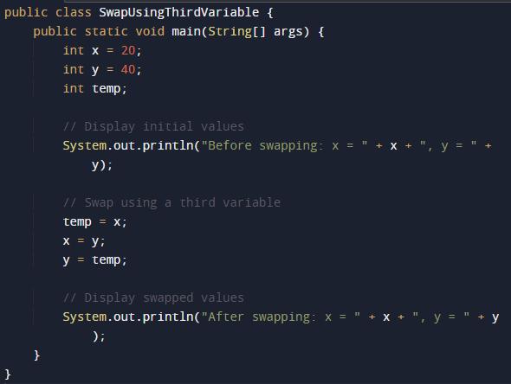

**Output :**



* Method without using a third variable:

Vijay prefers an approach that doesn't use an additional variable to swap his values. he also has two integer variables, a and b, with initial values a = 10 and b = 20. So, write an appropriate Java program to assist Vijay in swapping the values of a and b without using a third variable, and then display the updated values.

**Code :**

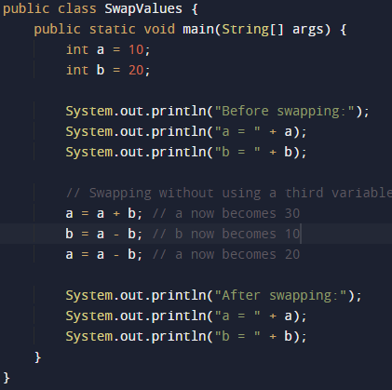

**Output :**

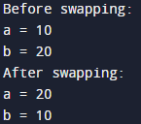

Q.2. Write an appropriate program to find the following without the use of loop and condition.

1.) Find addition, subtraction, Multiplication, and division of given two number that is 100 and 25.

**Code :**

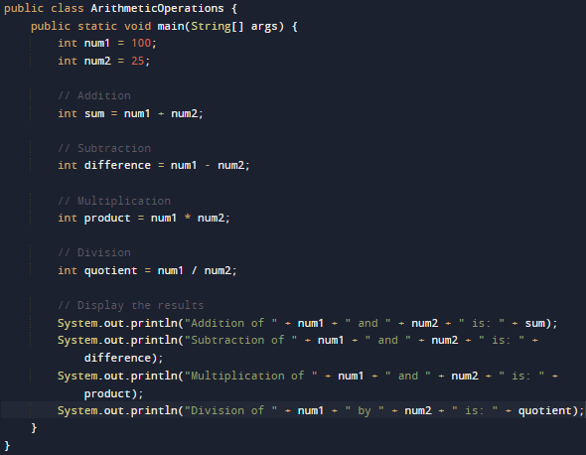

**Output :**

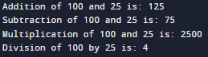

2.) Find addition of each digit number. [Note: One number given, that is :12345 Output should be: Addition of each digit is :15

**Code :**

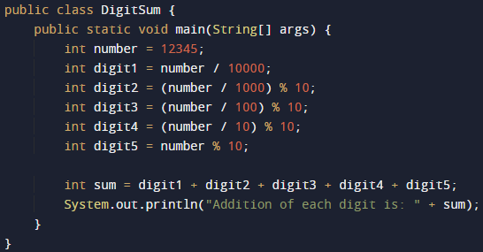

**Output :**



3.) Find alternate digit multiplication of given one five-digit number, that is 23456. Expected output should be:720

**Code :**

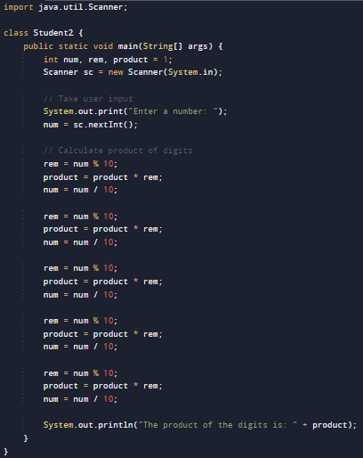

**Output :**



Q.3. Charlie and James are siblings who have recently received some money as a gift from their grandparents. Charlie decides to invest his money in a fixed deposit with a simple interest rate, while James chooses to invest her money in a savings account with a compound interest rate. They want to compare the growth of their investments after a certain period.

Q.3.1: Charlie invests $2000 in a fixed deposit account with a bank that offers a simple interest rate of 4% per annum. Calculate the total amount Charlie will have after 3 years. Assume that the interest is calculated annually.

Q.3.2: James invests $1500 in a savings account with a bank that offers a compound interest rate of 5% per annum. Calculate the total amount James will have after 4 years. Assume that the interest is compounded annually.

*(The formulae to calculate Simple Interest and Compound Interest are as follows:*

*Simple Interest (SI) = (Principal * Rate * Time) / 100*

*Compound Interest (CI) = Principal * (1 + Rate / 100)^Time – Principal)*

**Code :**

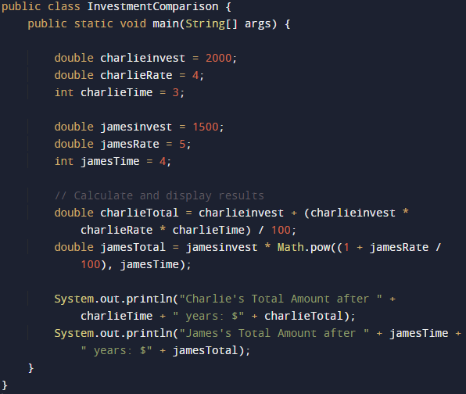

**Output :**

